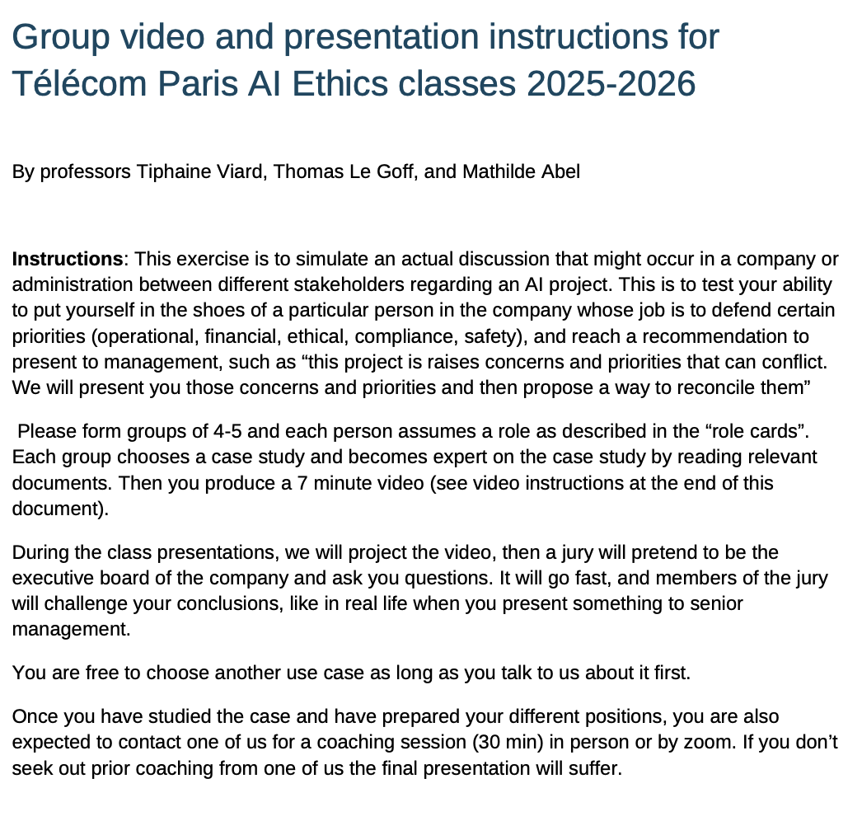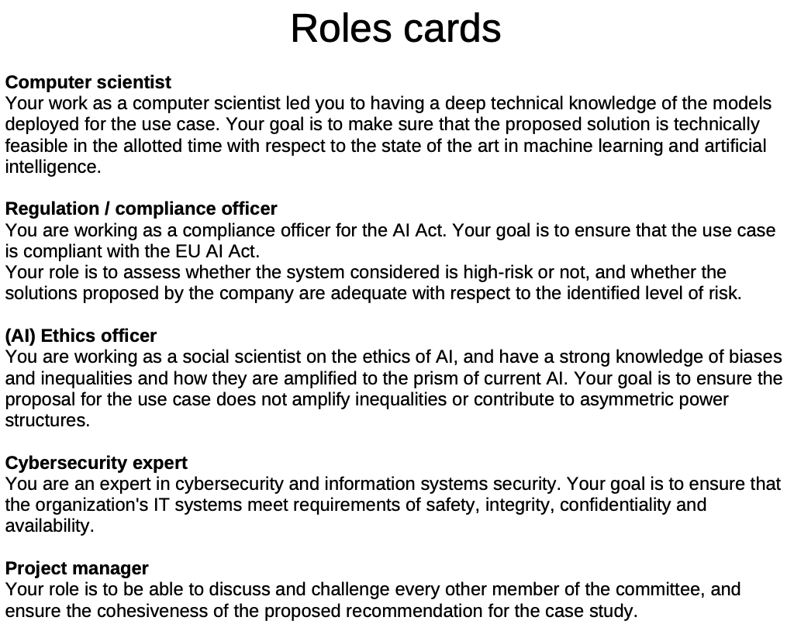

*** LLM-as-a-service platform in banking services
A banking company is developing an internal LLM-as-a-service platform for all its employees. The company chooses LLMs, whether open-source or proprietary, and makes them available for use by its employees from all services. Employees can then build applications based on the chosen LLM for their own needs. This can lead to various applications like customer-facing chatbots, credit scoring algorithms for granting loans to individuals, and credit card or financial fraud detection. The bank thinks that some AI use cases in banking can lead to ethical and legal risks, it wonders how to ensure AI applications are built and deployed by its teams while ensuring trustworthiness and legal compliance. The bank also wonders what organization and processes it should put in place to ensure that employees using the LLM-as-a-service platform develop and deploy AI applications ethically. Useful resources:

- https://cdn.ceps.eu/wp-content/uploads/2025/05/Unfit-for-purpose-ECRI-In-DepthAnalysis.pdf
- Ali, A., Abd Razak, S., Othman, S. H., Eisa, T. A. E., Al-Dhaqm, A., Nasser, M., Elhassan, T., Elshafie, H., & Saif, A. (2022). Financial Fraud Detection Based on Machine Learning: A Systematic Literature Review. Applied Sciences, 12(19), 9637. https://doi.org/10.3390/app12199637
- J. O. Awoyemi, A. O. Adetunmbi and S. A. Oluwadare, "Credit card fraud detection using machine learning techniques: A comparative analysis," 2017 International Conference on Computing Networking and Informatics (ICCNI), Lagos, Nigeria, 2017, pp. 1-9, doi: 10.1109/ICCNI.2017.8123782.
- https://www.solutions-numeriques.com/cas-dusage-dia-generative-bnp-paribas-met-en-placeen-interne-une-plateforme-de-llm-as-a-service/

